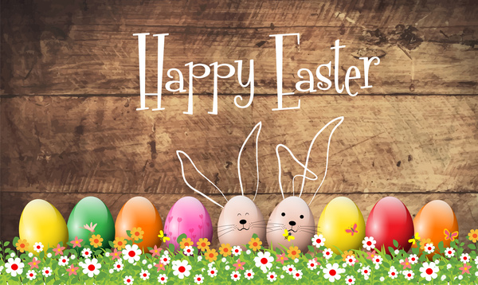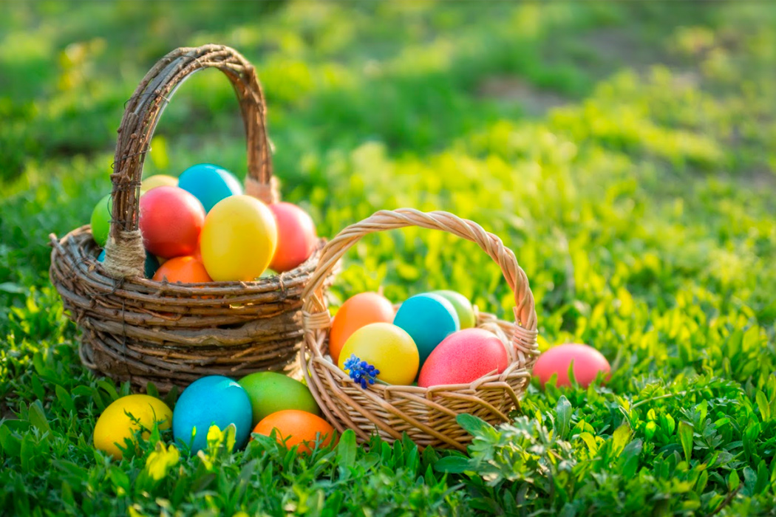

EYFS

Outdoor Activities

* Go for a ‘Spring walk’ What signs can you see that Spring is here? Can you collect 10 words about Spring and write them in a list?
* Easter hunt. Can you hide an egg or a cuddly toy outdoors and write a clue for your adult to follow? Sound your words out and don’t forget your finger spaces.
* Can you choose something to draw and sketch it carefully? It could be a tree or a flower, anything you want!
* Can you make up an exercise routine for your family. Give them instructions but make sure you join in too! Eg. March for 1 minute, do 5 bunny hops, turn around, flap your wings (arms) etc

Any other ideas…

Easter Crafts

* Read the Easter story so that you know why we celebrate Easter. Read Easter themed stories with your adult. ‘Saving Easter’ on Twinkl is a good one.
* Easter songs – look on class dojo and we will suggest some of our favourites.
* Easter baking – can you follow instructions and make chocolate crispie or cornflake nests?
* <https://www.topmarks.co.uk/Easter/> Can you play the Easter counting games?
* <https://www.activityvillage.co.uk/easter> Complete some of the Easter puzzles on this link.
* Draw an egg shape and then put a number 1to 10 at the

top let the children put the correct number of objects on

the egg

* Can you make an Easter card for your family. Write a message inside your card to wish them a ‘Happy Easter’
* Make your own entry for the school ‘Egg challenge’. Boil an egg and decorate it however you would like, then take a photo and send it to your teacher on class dojo.
* Can you find some unwanted boxes, tubes, lids etc and make a model? How about making a rabbit, a chick or an Easter basket? Look at the boxes you have got before you decide. For more ideas look at:<https://www.twinkl.co.uk/resource/t-t-18368-spring-craft-activity-pack>
* Play pin the tail on the rabbit or roll the egg into hunger

rabbit and count how many eggs he has eaten at the end

of the game