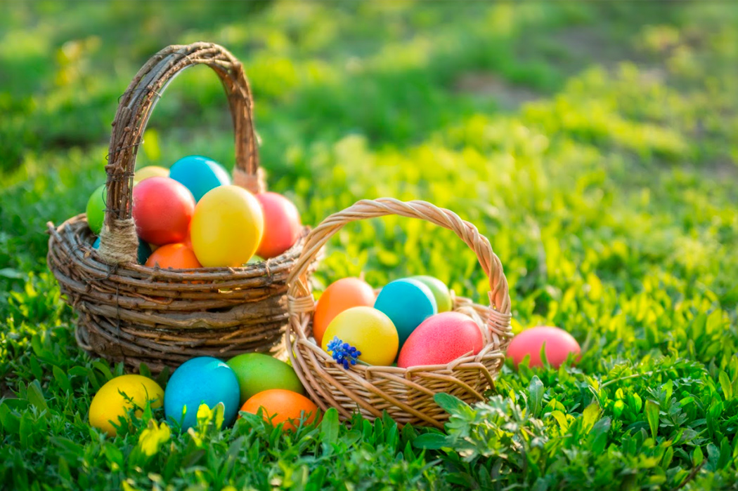

Year 1/2

* Listen to the Easter Story - <https://www.bbc.co.uk/teach/class-clips-video/religious-studies-ks1-the-christian-story-of-easter/zhgv47h>
* Can you retell the Easter Story?
* You could draw a picture to show part of the Easter Story and label the important people?
* Try some of these lovely Easter E-Books on Twinkl - <https://www.twinkl.co.uk/resource/the-easter-journal-ebook-t-or-1135>
* Make playdough and create an Easter scene.
* Can you create an Easter board game? Write a set of instructions and the rules of the game. Play your game with your family.

Useful websites:

<https://www.topmarks.co.uk/Easter/>

- for activities about Easter customs and traditions, as well as the Easter story

<https://www.activityvillage.co.uk/easter>

- downloadable colouring activities and lots more

<https://www.hearthandmade.co.uk/free-printables-for-easter/>

- free printables for Easter

<https://www.teachstarter.com/gb/blog/free-funky-easter-egg-craft-activity-gb/>

- Easter egg craft - we like this one!

* Make your Easter Egg for the Easter Egg challenge – decorate it in any way you would like then send a photo on dojo to your teacher.
* Paint or colour a paper plate to make an Easter Rabbit.
* Design an Easter Card for your family.
* Design and make an Easter Bonnet – this was something we always loved to do as a child.
* Make salt dough Easter decorations – eggs, rabbits, lambs, cross.
* Bake an Easter cake or buns to share with your family – Maybe link with your friends through ZOOM to do this together?

Easter Crafts

* Go on a nature walk in the sunshine, what can you find? What different sounds can you hear?
* Make a tent or fort outside in the sunshine. What different materials will you use?
* Take photos of signs of Spring while on your walk. Now write some information about what you have seen.
* Go on an Easter Egg hunt – can you design one then ask your family to find the eggs. If you don’t have eggs, you could use other objects.

Outdoor Activities

Any other ideas…